Budget Rent-a-Car
of British Columbia

Optional Extra Maintenance Tutorial

Version 1.00

Note: The information contained in this document is confidential and may not be disclosed to any parties outside of Budget Rent-a-Car of British Columbia Ltd. without written consent by one of its officers.

Copyright (C) 2011 Budget Rent-a-Car of British Columbia Ltd.
Table of Contents

1 Creating Optional Extras 1
2 Assigning Optional Extras 1
3 Defining LDW Deductibles 3

1 Creating Optional Extras

The Optional Extra Maintenance screen allows for the definition of Optional Extras and their associated GL accounts, fees and taxes. These optional extras may be referenced for use in reservations and contracts. This screen is accessible from the Rate Control menu.

To create an optional extra, enter its name in the Optional Extra field at the top of the screen. For each optional extra that you add, identify its Type by selecting from the drop down. The Maximum Quantity field allows you to control the rental limit for that particular optional extra in each rental. For example, you would enter 1 in this field for a GPS optional extra if you only allow a single GPS unit for rent in each contract. GIS will automatically pop up a validation message should the user attempt to add more than the specified maximum quantity for an optional extra.

Record the GL Account Number for the optional extra you are adding for both car and truck. Note that this GL Account Number should also be set up in the accounting software of your choice for reference.

NOTE
Account numbers in GIS are structured into three levels, as shown below.
Account Number
Vehicle Class Account Segment
Location Account Segment

NNNNN—XX—YY

Let’s use baby seat as an example. Assume its account number for car is 7003.

- Simple account numbers without any dependencies on location or vehicle class will take the form of NNNN (where N is a string of digits). So you would enter only 7003 in the GL Account Number field for baby seats.

- If your accounting is based on location, then your account number will omit the Vehicle Class Account Segment. So you would enter 7003-XX in the GL Account Number field for baby seats. The XX is just a syntax and it will pick up the actual account segment from the Location Maintenance module.

- If your accounting is based on location and vehicle class, then you would enter 7003-XX-YY in the GL Account Number field for baby seats. The YY is just a syntax and it will pick up the actual account segment from the Vehicle Class module.

Specify the Daily Rate and Weekly Rate amounts for the optional extra. A Valid From date is also required for each entry. Note that your Valid From date cannot be earlier than the current date. The Valid To field can be left empty if the optional extra is available indefinitely.

Here comes the tricky part – the HST Exempt field. There are two types of HST in British Columbia – the regular HST of 12% and the special HST of 5% for baby/child seats and fuel. The HST Exempt box refers to the 12% HST and it is unselected by default. If you want to apply the 5% HST for an optional extra, you would need to select the HST Exempt box.

Audit information is visible at the bottom of the screen. See the figure below for an example of a newly created optional extra called Baby Seat.

NOTE
The Define LDW Deductibles button will always be grayed out unless the optional extra’s Type is set to ‘LDW’.

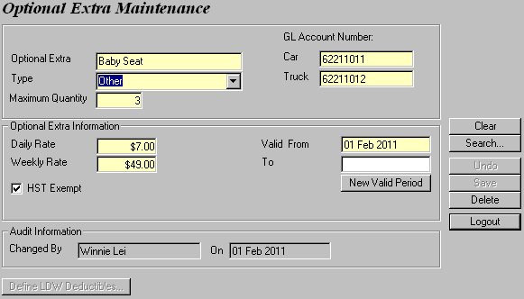
Figure 1: Creating an optional extra.

The New Valid Period button allows the user to create a new Valid To/From period. Clicking it defaults the new Valid From date with the day after the old Valid To date but contiguity is not required. If the current Valid To date is null then the user will be forced to enter it before creating a new time period.

NOTE
You cannot backdate your Valid From date.

You may search for any optional extra you created in the system via the Seach tool on the right hand side of the screen. Optional extra information may be searched by the optional extra’s name, type, valid from and valid to dates.

2 Assigning Optional Extras

After you add an optional extra, you have to make it available for rental for the vehicle classes you want through the Vehicle Class screen (See Figure 2).

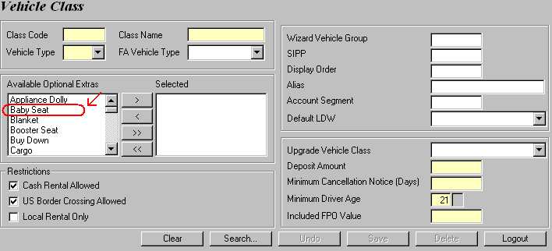
Figure 2: Any optional extra you create will appear in the Available Optional Extras column for selection.

Let’s assume that the Baby Seat we created above is an available add-on for rentals involving a Full Size 4Door. Now, bring up the Vehicle Class screen from the Fleet Control/Inventory menu. Then, retrieve the Full Size 4Door vehicle class through the Search button.
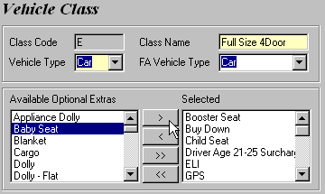
When the vehicle class information is populated, select Baby Seat and click on the > arrow to move it from the Available Optional Extras column to the Selected column, as shown in the figure to the left.

Figure 3: Assign the item to a vehicle class by moving it to the right.

Hit Save to save your changes. This optional extra will now be available for selection when you make reservations or open contracts at any rental location involving a Full Size 4Door for dates on/after the optional extra’s Valid From date, as shown in Figures 4 and 5.

NOTE
To remove the item, simply select Baby Seat and click the opposite arrow < to move it back from the Selected column to the Available Optional Extras column.
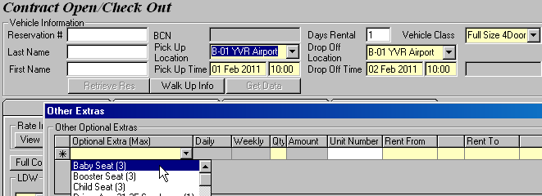
Figure 4: The optional extra is now available for selection in Contract Open (and Contract Changes) if the customer wants to rent a Full Size 4Door.

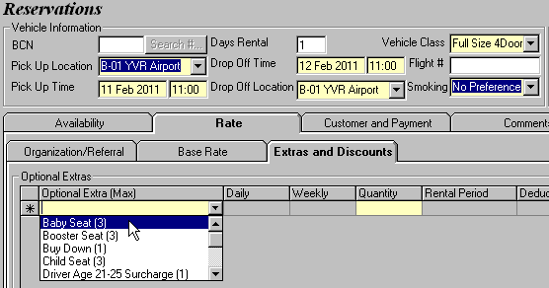
Figure 5: The optional extra is now available for selection in Reservation if the customer wants to rent a Full Size 4Door.

Repeat the same steps if you want to make any optional extra available for other vehicle classes.

3 Defining LDW Deductibles
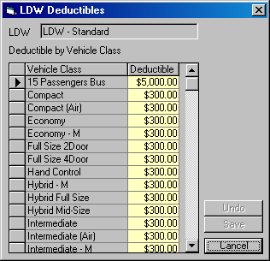
Once you finish creating an LDW optional extra, clicking on the Save button will invoke the LDW Deductibles window, as shown in Figure 6. This pop up screen allows you to define LDW deductibles for each vehicle class in the system. Populate the entire Deductible column and save your changes when you are done.

Figure 6: Defining LDW deductibles for each vehicle class.

NOTE
Every time you create a new vehicle class, it will automatically be added to the left column of the LDW Deductibles table in Figure 6. So be sure to return to this screen to update the deductible for your new vehicle class.

If this LDW is added to a contract, the deductible associated with the vehicle class will appear on the Contract Open screen (See Figure 7) and will be printed on the rental agreement (See Figure 8).

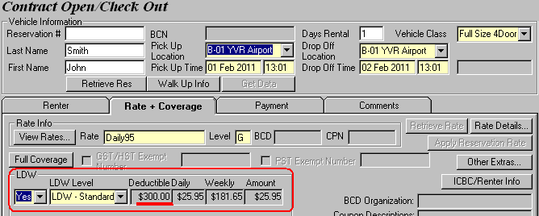
Figure 7: GIS displays the deductible for the selected LDW and vehicle class according to the LDW Deductibles table.
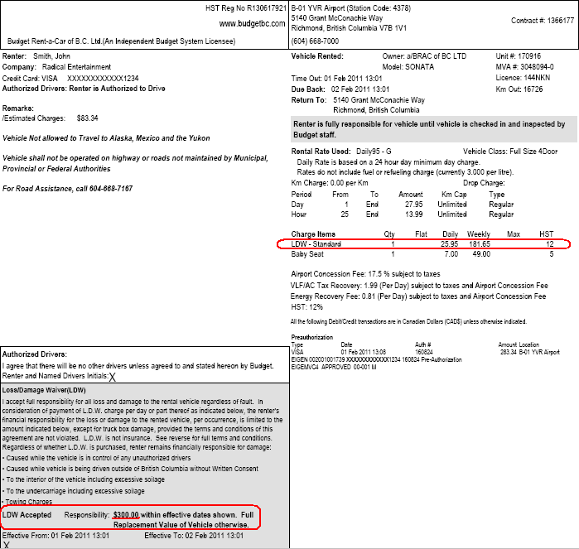
Figure 8: The deductible is also printed on the rental agreement.

